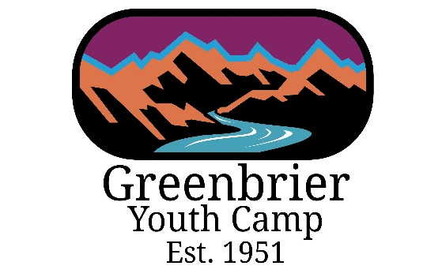
2022 “DYD” Camper Registration
Campers Name:
Birth Date:
Home Phone Number:
Email Address:
Desired Name Tag:
Primary Address: | Street:  City:  State:  Zip Code:

Camp Shirt Size:
Dietary or Medical Restrictions:
How did you hear about Camp?

Contact Phone Number:
E-mail Address:
Emergency Contacts Name:
Emergency Contact Phone Number:
Relationship to Camper:

I Agree to Waiver and Consent Form: | Signature:
Camp Fee: $140.00  *All Proceeds aid in the therapeutic for students that attend the Green River Academy. | Mail Camp Fee to:  Rebekah Lilly  722 Main Street East  White Sulphur Springs, WV 24986
Email Registration Form to: | Brightstarts2020@gmail.com

